# Weekly Project Meeting Minutes

*The main purpose of the document is to capture all the work that has been done by the group over the course of one week and* ***not*** *to write down what was discussed in a single meeting. You should be meeting and/or working throughout the week*.

Time group spent on project: ___7.5 hours____________

Group Number: 01

Group members present (Name, ID):

* Jasleen Jasleen (0734327)
* Arvind Sharma (0730475)
* Harpreet kaur (0733894)

Specific Activities from prior week:

* List brief description of activities carried out **by group member**
* After searching on the dataset, we have finally come to the solution which dataset we are selecting the dataset from the federal financial institutional examination council 2016.
* As discuss in the previous week, we have meeting with Mubeen Professor of university of Windsor who currently is working in Scotia bank as a Senior Financial Advisor for Investment and Mortgage loan.
* He discusses what type of question is asked when customer walk in to ask for a loan is how much money he make, where is Credit score stands or if he or she has declared bankruptcy.
* So, after that if the person is bankrupt, he or she will not get loan at any chance.
* He also discuss the problem customer has to face when applying for a loan.

Specific Output from prior week:

* Include brief summary of any written work, experiments, or code developed

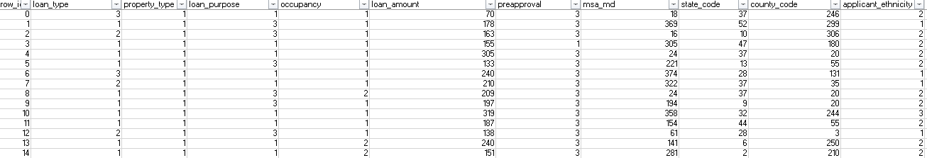

* Attach actual output as a separate file when submitting minutes; for example, export your Jupiter notebook as an html file and upload that with your minutes

We do not have the jupyter notebook this week.

On Target:

* Indicate the current status of your project
  + _____ green: everything on track for completion by due date



* + _____ yellow: a small number of tasks are off track and completion by due date is at risk
  + _____ red: many tasks are off track and project will not be completed by due date

Challenges/Disagreements:

* List any particular challenges identified/discussed and possible solutions
  + include tasks causing a yellow or red flag for your project

As last week we have the challenge with the project topic everyday we face a new challenge with the project . We have spent a lot of time on selecting the dataset for the project.

We have checked online the previous work done on the mortgage loan approval , more than 5 people has work on loan approval not particular on mortgage so after finding from GitHub we came across the right dataset and solve this challenge

* List any notable disagreements and subsequent discussion and resolution

This week we do not have any kind of disagreement in our project , everything went smooth and simple.

Planned Activities for coming week:

* List brief description of activities **by group member**

Next week we will load the dataset into python file and will start overview and data description about the data because before dealing with the dataset we should have the full knowledge about the dataset and what is happening how the column are related to each other which has higher and least importance .

After that we are planning to do the data cleaning and data preparation.

* Make sure tasks are assigned to address yellow and red flag items

Surely the task is assigned to green flag.

References:

* <https://spivey.io/samantha/portfolio/predicting-home-loan-approvals-2019-05-09>
* <https://Github.com/>S